Go to **IAM console** and click on create **Credential report** on corner the left side of the page.

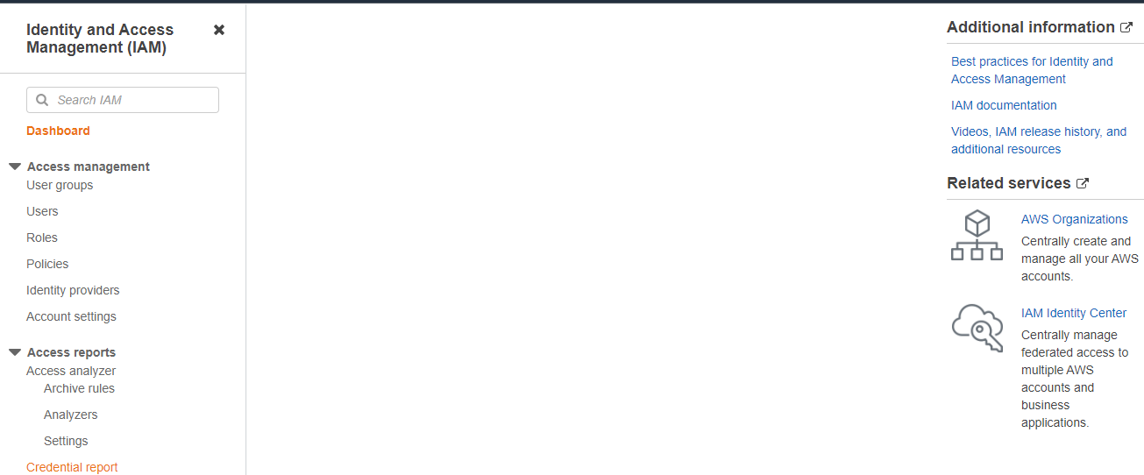

* Click on download report

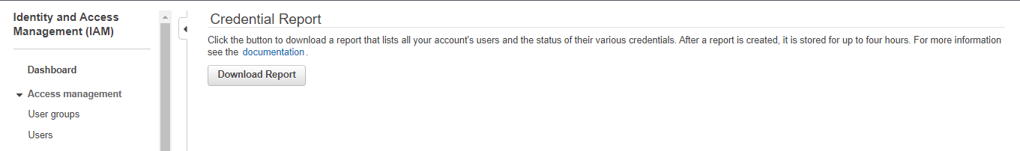

We can see account status

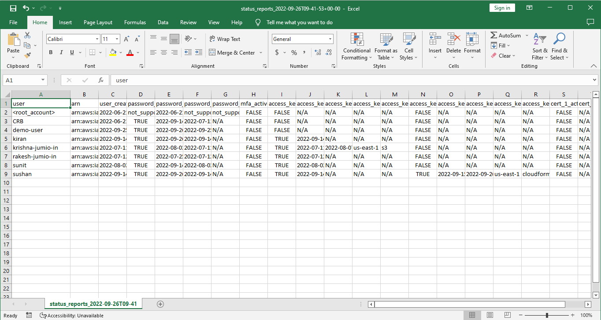

* Go to IAM console.
* Click on User.
* Click on our user name demo-user

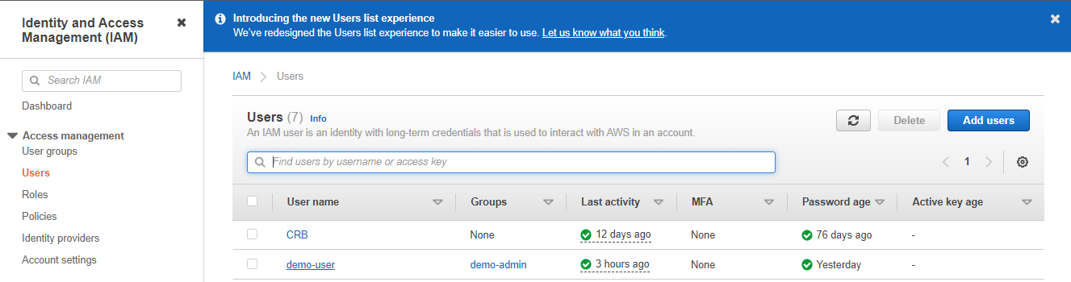

Click on Access-Advisor

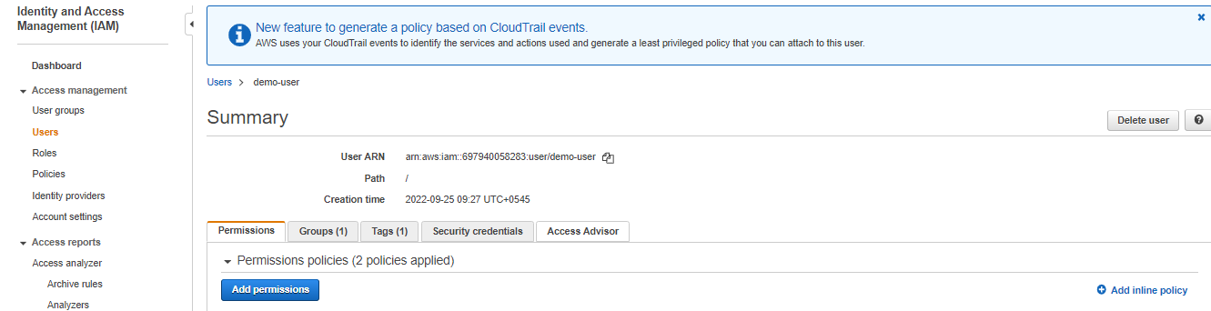

You will see activated service .

